PROVIDER CONNECT – PROVIDER BILLING REPORTS

Main Menu
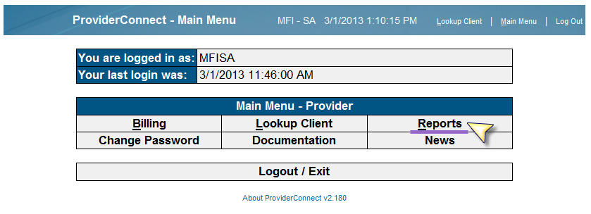

Reminder that Provider Connect has reports that identify services that have been billed and what has not been billed in the Reports Menu under “Provider Billing Reports”

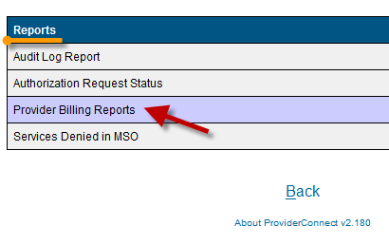

Billed services will show everything that has been billed to the County for payment.

Unbilled services will show what services have been entered and to which Program ID/Reporting Unit (RU). This report can be used to confirm the right services have been entered to the right (RU) BEFORE a bill is generated. If there are any errors, they can be fixed before generating the bill for submission to the County.

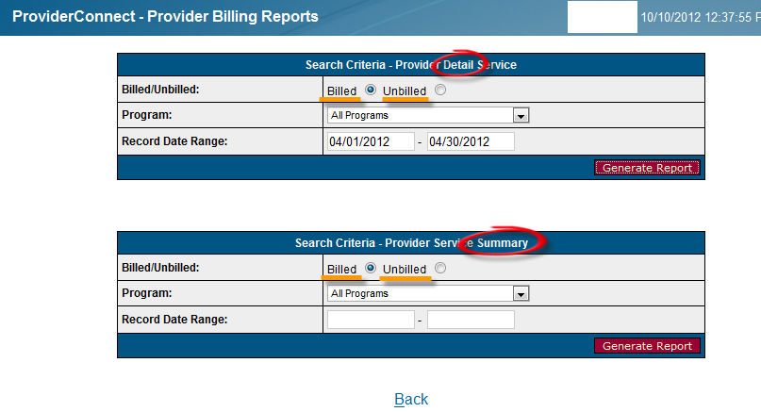
Select either Detail or Summary listing.

SUMMARY VIEW

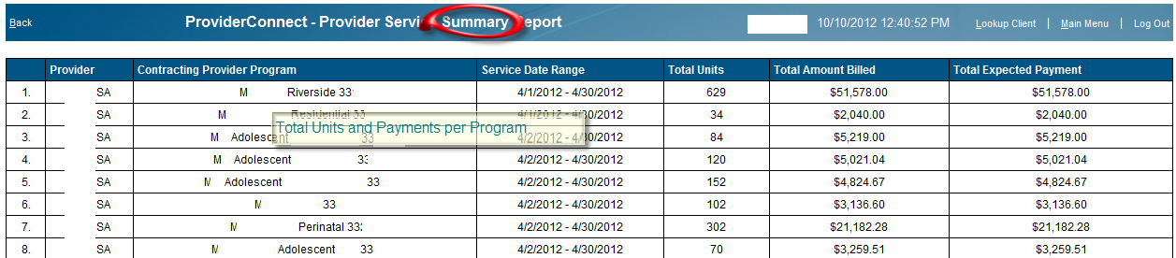

Breakdown of total number of units processed and total expected payment (paid amounts) per program id.

DETAIL VIEW

BILLED
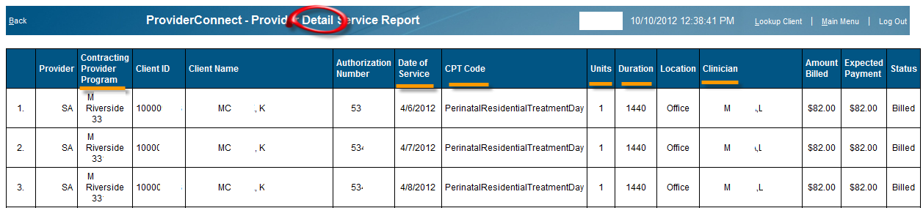

UNBILLED
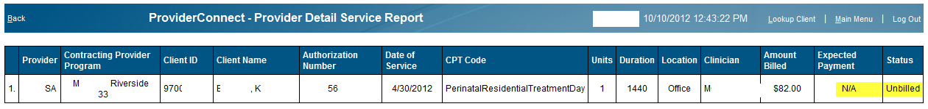

Review all data to ensure that claim line is accurate. This will minimize in billing errors and delay in invoice processing. Make sure that the correct Contracting Provider Program is selected, the correct service code to units and duration, date of service, as well as clinician who rendered the service. Review for any invalid duplicates on the bill. Once review of this report is complete and service edits/deletions made, generate your monthly bill for submission to the County.

Convert to Excel for sorting if needed -
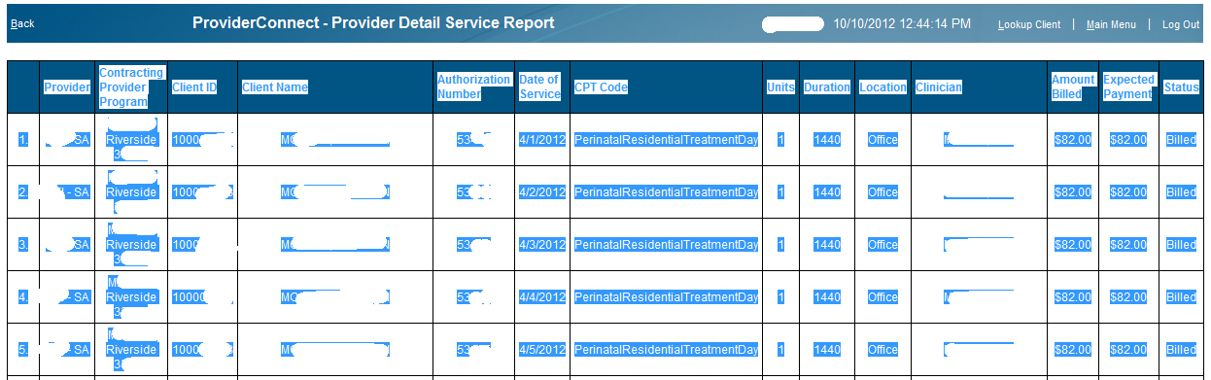
Highlight the data in the Provider Connect report table. Right Click and select “Copy”.

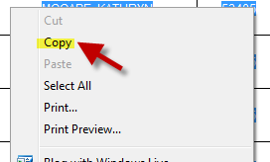

Open Excel. Right Click on worksheet and select “Paste”
